

PROJECT REPORT
On
JobAspire(Job Portal)
Submitted in partial fulfilment of the requirement for the
Course Web Development of
COMPUTER SCIENCE AND ENGINEERING

B.E. Batch-2022

in
June2025-Dec2025



Under the Guidance of Submitted By

Mr.Sudeep Arpita
Roll. No: 2210991359
Mentor Arshika
Roll. No: 2210991369
Kanika
Roll. No: 2210991735
Rishika
Roll. No: 2210992164

DEPARTMENT OF COMPUTER SCIENCE AND ENGINEERING
CHITKARA UNIVERSITY
PUNJAB

CERTIFICATE

This is to be certified that the project entitled “E-commerce Website” has been submitted for the Bachelor of Computer Science Engineering at Chitkara University, Punjab during the academic semester June
2025-December-2025 is a bonafide piece of project work carried out by Arpita(2210991359),Arshika(2210991359)
Kanika(2210991735), Rishika(2210992164) towards the partial fulfillment for the award of the course Integrated Project (CS 203) under the guidance of “Mr.Sudeep” and supervision.

Sign. of Project Guide :
Mr.Sudeep

CANDIDATE’S DECLARATION

We, Rishika(2210992164), Ritika(2210992167), Riya Raj(2210992173) B.E.-2021 of the Chitkara University, Punjab hereby declare that the Integrated Project Report entitled “JobAspire-A Job Portal” is an original work and data provided in the study is authentic to the best of our knowledge. This report has not been submitted to any other Institute for the award of any other course.

Sign. of Student 1 Sign. of Student 2 Sign. of Student 3 Sign. of Student 4
Arpita Arshika | Kanika | Rishika
2210991359 2210991369 | 2210991735 | 2210992164

Place:
Date:

ACKNOWLEDGEMENT

It is our pleasure to be indebted to various people, who directly or indirectly contributed in the development of this work and who influenced my thinking, behavior and acts during the course of study.

We express our sincere gratitude to all for providing me an opportunity to undergo Integrated Project as the part of the curriculum.

We are thankful to Ms. Dimple Kapoor for her support, cooperation, and motivation provided to us during the training for constant inspiration, presence and blessings.

We also extend our sincere appreciation to Ms. Dimple Kapoor who provided his valuable suggestions and precious time in accomplishing our Integrated project report.

Lastly, We would like to thank the almighty and our parents for their moral support and friends with whom we shared our day-to day experience and received lots of suggestions that improve our quality of work.

Sign. of Student 1 Sign. of Student 2 |  | Sign. of Student 1 Sign. of Student 2
  Arpita Arshika | Kanika | Rishika
  2210991359 2210991369 | 2210991735 | 2210992164
  Kanika Rishika | Kanika | Rishika
  2210991735 2210992164 | 2210991735 | 2210992164

- Abstract/Keywords

- Introduction to the project

  - Background

  - Problem Statement

- Software and Hardware Requirement Specification

  - Methods

  - Programming/Working Environment

  - Requirements to run the application

- Database Analyzing, design and implementation

- Program’s Structure Analyzing and GUI Constructing

- Code-Implementation and Database Connections

- Conclusion

- Future Scope

- Bibliography/References

Abstract

JobAspire is an innovative online job portal designed to transform the way job seekers and employers connect and interact. By offering a user-friendly interface and incorporating essential recruitment functionalities, JobAspire delivers a seamless and efficient experience for both job seekers and employers.

The platform leverages modern web technologies, including React.js for a dynamic and responsive front-end experience, Node.js and Express.js for efficient server-side processing, and MongoDB with Mongoose for scalable and flexible data management.

Engineered with a focus on scalability and security, JobAspire is designed to accommodate a growing user base while ensuring the protection of sensitive data through robust encryption measures and secure authentication mechanisms.

Future enhancements may include AI-driven job recommendations, a mobile application for easy access, and advanced analytics features to help employers identify the best candidates. Additional community-oriented features, such as forums for career discussions and reviews, may also be integrated.

By offering a comprehensive and intuitive platform, JobAspire aims to meet the diverse needs of job seekers and employers, creating a secure, scalable, and engaging solution for the evolving job market.

- Introduction to the project:
In today’s fast-paced digital world, job seekers and employers face numerous challenges in connecting effectively. The abundance of job portals often leads to confusion, as users navigate through different platforms, each with its own interface, application processes, and communication methods. This fragmentation complicates the recruitment process, making it difficult for job seekers to find relevant opportunities, receive personalized recommendations, and track application progress.

Similarly, employers struggle with managing job postings, screening candidates, and efficiently tracking applications. The lack of an integrated and user-friendly solution hampers the overall efficiency and experience for both parties involved.JobAspire aims to address these challenges by providing a centralized, intuitive, and feature-rich platform that simplifies and enhances the job search and recruitment process for all users.

  - Background:

In today’s digital landscape, job seekers and employers often rely on multiple platforms to manage job searches, postings, and applications. This fragmentation creates inefficiencies and complexities, as users must navigate different websites with varied interfaces, application processes, and communication methods. As a result, job seekers face difficulties in finding relevant opportunities and tracking their applications, while employers struggle to manage candidate profiles, track recruitment progress, and efficiently communicate with applicants.

JobAspire was conceived to address these challenges by offering a unified job portal solution, consolidating key features such as job searching, application tracking, and employer-candidate communication into a single, user-friendly platform. By streamlining these processes, JobAspire ensures a seamless and efficient experience for both job seekers and employers, while maintaining a strong focus on security, scalability, and user convenience.
  - Problem Statement

The JobAspire project aims to create a fully functional backend system for an online job portal. This project will focus on building a robust and scalable backend infrastructure, including user authentication, job posting management, candidate application tracking, and employer-candidate communication. The goal is to provide a seamless user experience by ensuring efficient data management, real-time updates, and secure transactions, while enabling job seekers and employers to easily interact and manage their profiles and applications.

3. Software and Hardware Requirement Specification

Software Requirements:
- Operating System: Windows, macOS, or Linux.
- Code Editor: Visual Studio Code (VS Code).
- Backend: Node.js, Express.js.
- Frontend: React.js, HTML, CSS, JavaScript.
- Database: MongoDB, Mongoose.
- Version Control: Git.
- Browser: Chrome, Firefox, or any modern browser.

Hardware Requirements:
- Processor: 2 GHz or faster.
- RAM: Minimum 4 GB.
- Storage: 1 GB of free space.
- Network: Stable internet connection.

Methods
- Agile Development: Iterative cycles for flexibility and user feedback.
- Modular Design: Separation of frontend, backend, and database for easier maintenance.
- API-Driven Development: REST APIs for client-server communication.

Programming/Working Environment
- VS Code: Main environment for writing and managing code.
- Terminal: For running Node.js and React.js commands.
- Browser DevTools: For inspecting and debugging frontend code.

Requirements to Run the Application
- Install Node.js and use npm for dependencies.
- Set up MongoDB for database management.
- Run the backend with npm run start and the frontend with npm start in VS Code.

- Database Analyzing, design and implementation:

Database Analyzing
  - Data Requirements: Identify key data entities such as users, posts, comments, and messages.
  - Relationships: Understand the relationships between these entities (e.g., a user can have multiple posts, comments, and messages).
  - Data Structure: Define how data will be stored, retrieved, and managed efficiently, focusing on scalability and real-time updates.
Database Design
  - Database Model: Use MongoDB, a NoSQL database, to store data in a flexible, JSONlike format.
◦ User Collection: Stores user details like username, email, password (hashed), profile information, etc.
◦ Order Collection: Contains orders made by users, with fields for content, timestamps, and user references books.
◦ Message Collection: Handles private messages between users, with references to sender and receiver.

Database Implementation
  - Mongoose Integration: Utilize Mongoose ORM in the backend to manage MongoDB collections and schemas.
◦ Create models for each entity (User, Post, Comment, Message) using Mongoose, ensuring efficient interaction with the database.
◦ Implement data validation, indexing for fast queries, and reference linking between documents for related data.
  - CRUD Operations:
◦ Create: Users can create accounts, posts, comments, and send messages.
◦ Read: Users can retrieve posts, comments, and messages.
◦ Update: Users can edit their profiles, posts, and messages. ◦ Delete: Users can delete posts, comments, and messages.

- Program’s Structure Analyzing and GUI Constructing Program Structure:
The program follows a classic full-stack web application architecture, consisting of the frontend, backend, and database layers. The frontend handles the user interface, the backend processes requests and responses, and the database stores user data.
Frontend: Built using React.js with a combination of HTML, CSS, and JavaScript for dynamic user interaction. Key UI components include user profiles, posts, messaging windows, and notifications.
Backend: Developed with Node.js and Express, the backend manages API requests, routes, and user authentication.
Database: MongoDB is used for storing user information, posts, messages, and other data, allowing for flexible and scalable data storage.

GUI Constructing:
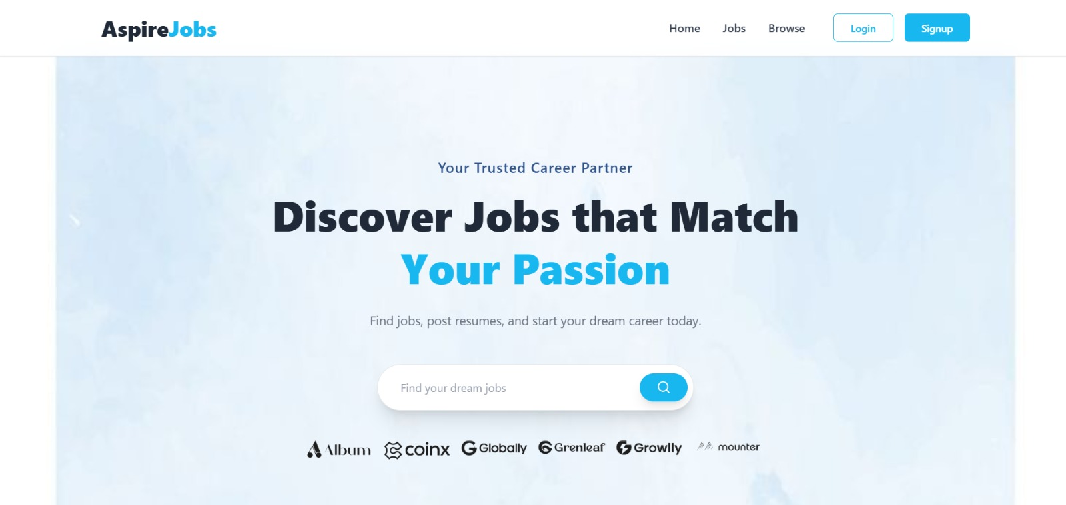

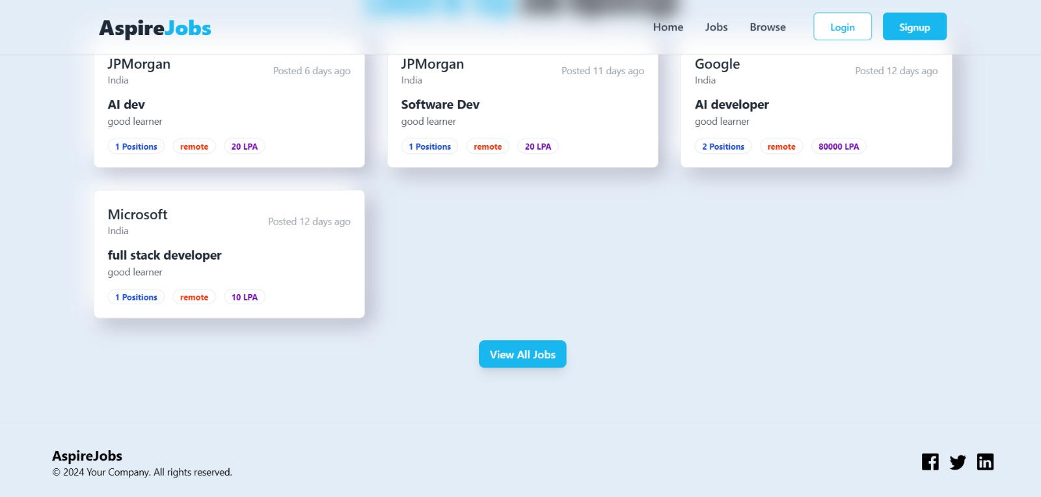

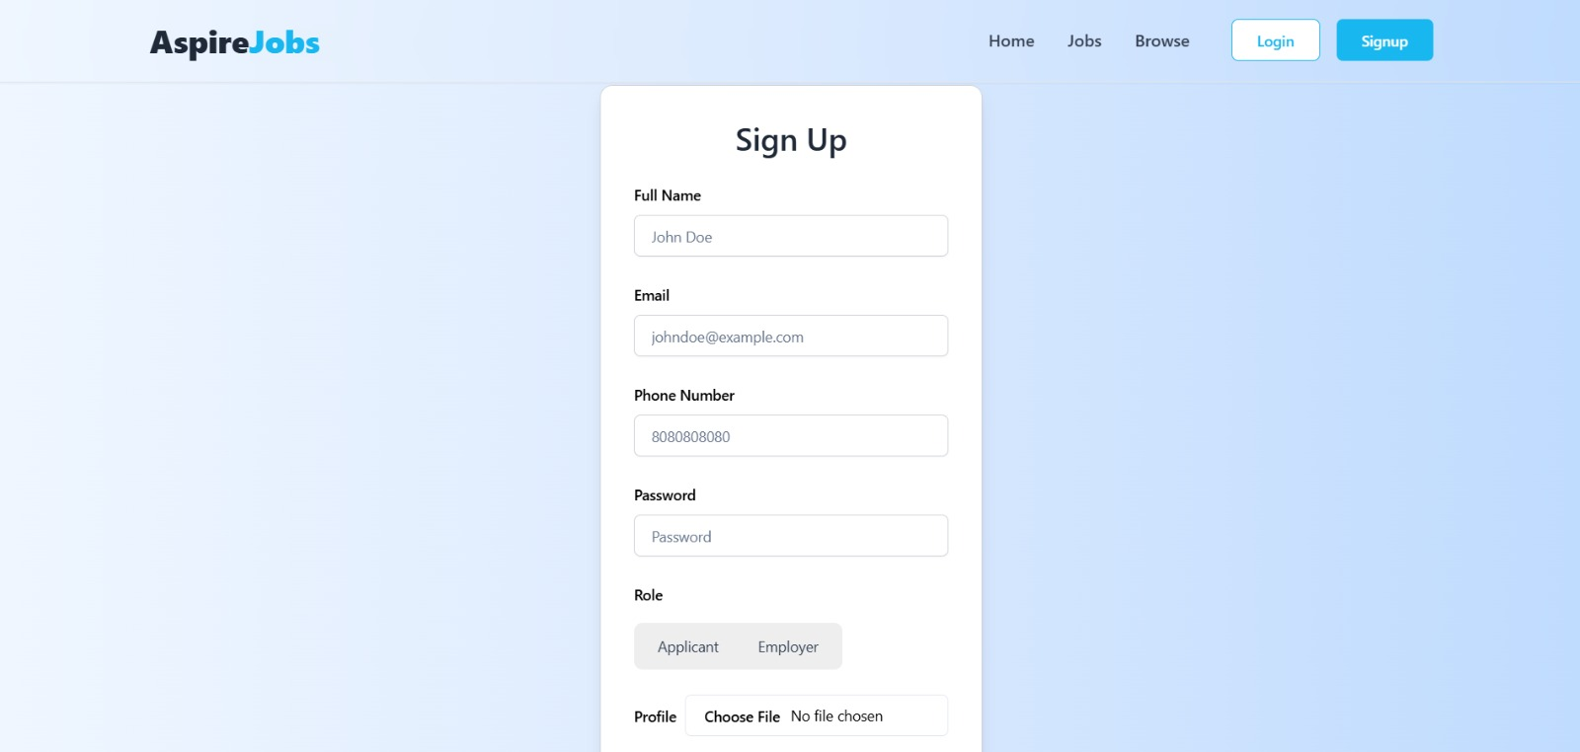

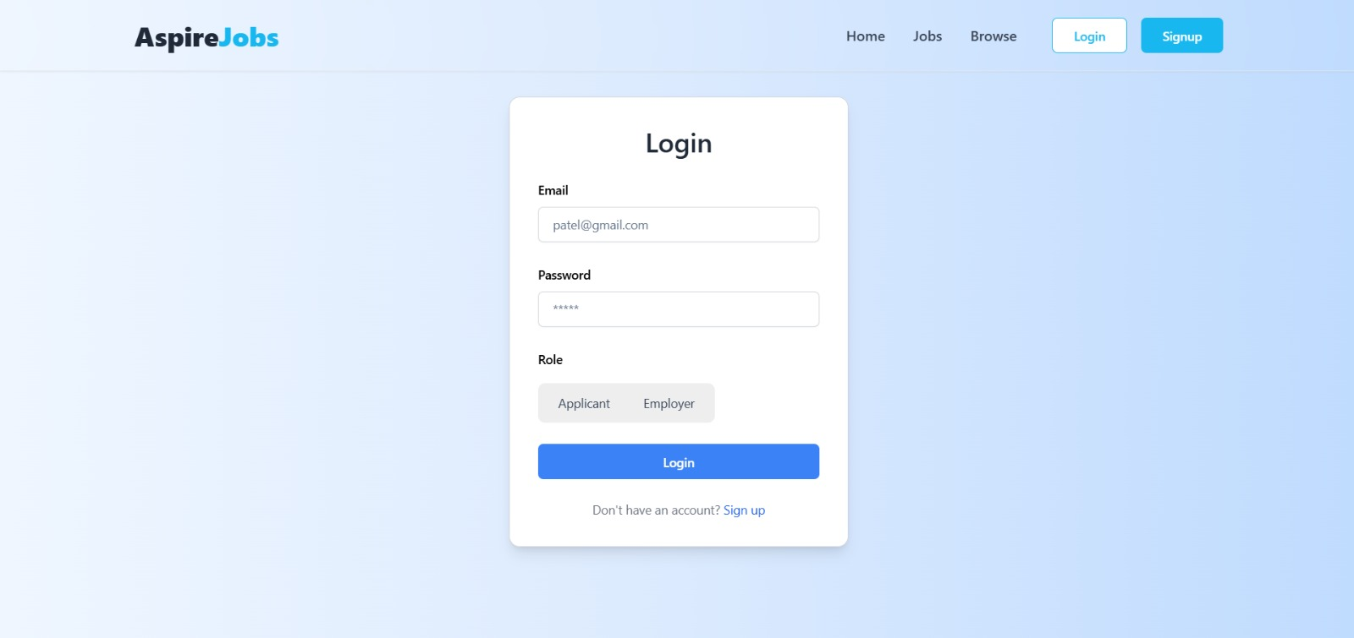

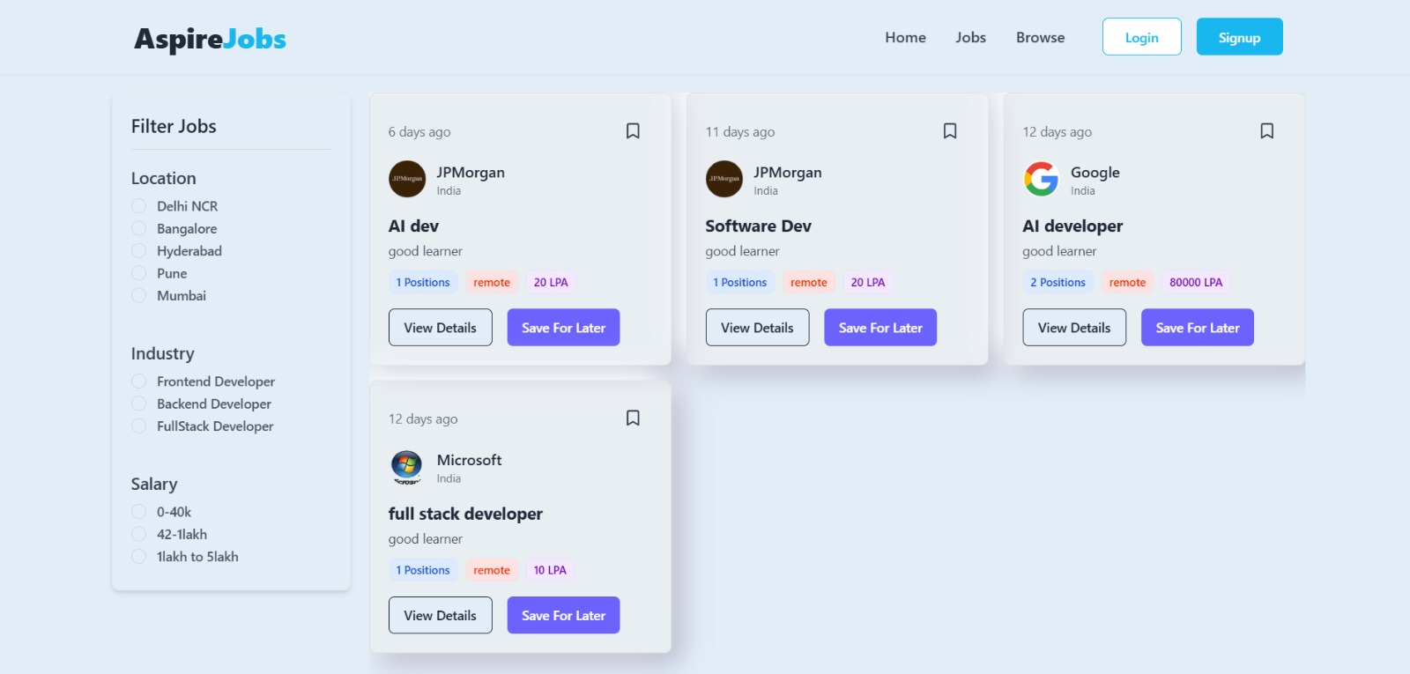

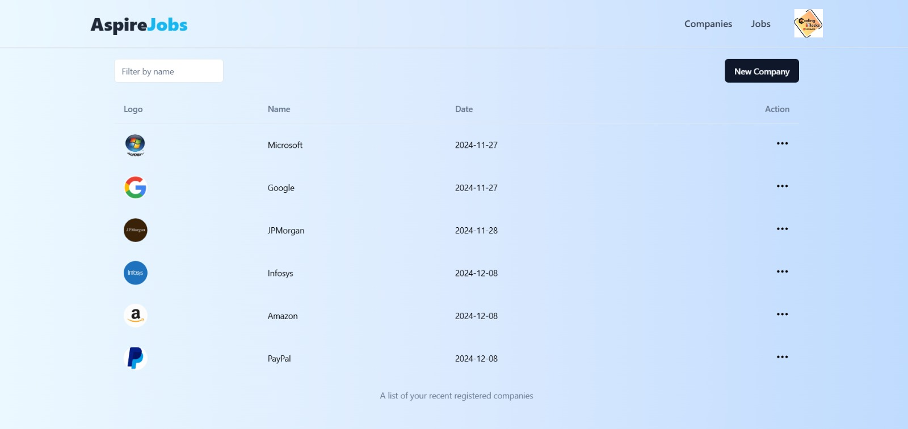

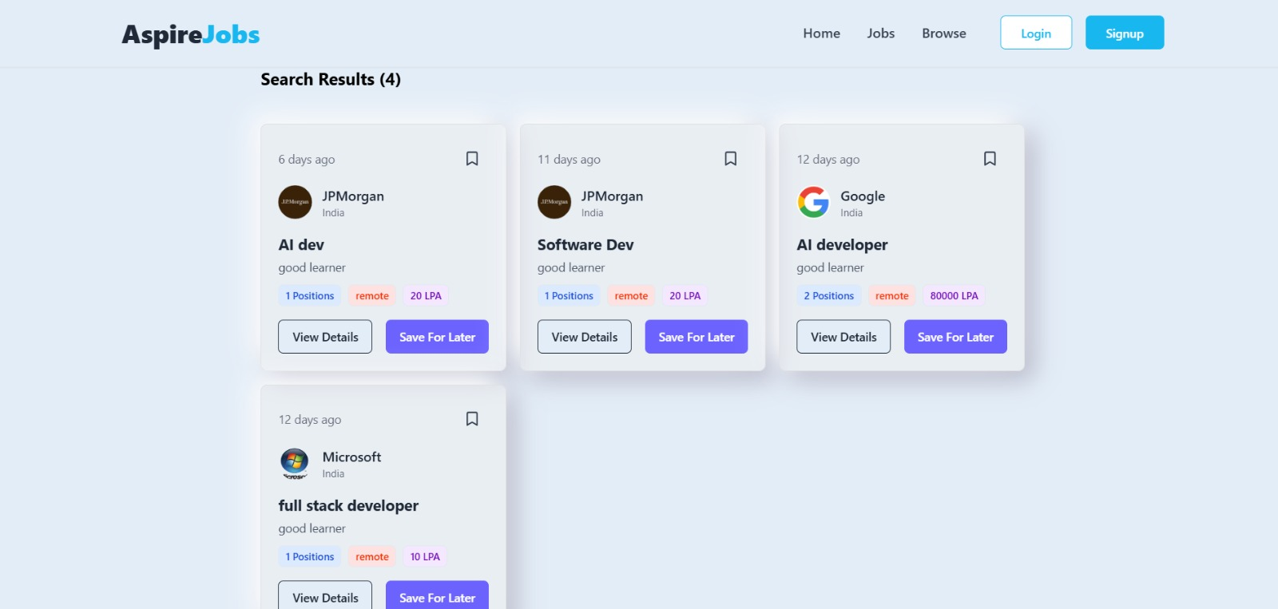

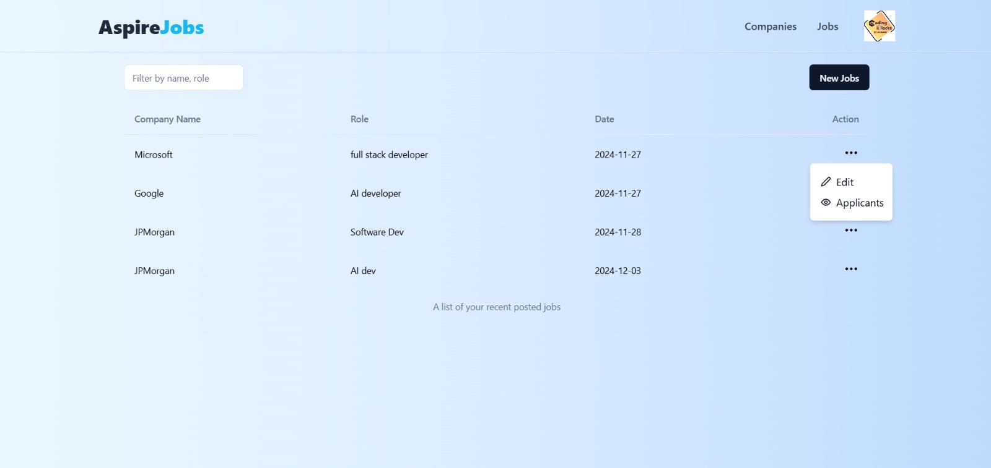

6. Code-Implementation and Database Connections :

Code Implementation:
- The frontend is implemented using React.js. Core components such as Navbar, User Profile, Message List, and Post Feed are developed as separate reusable components.
- CSS and Tailwind CSS are used for styling and creating a responsive layout that adjusts according to screen size.
- Node.js with Express handles server-side logic. API routes for features like user login, post creation, and messaging are defined in the Express.js routes.

- JWT (JSON Web Token) is used for user authentication, ensuring secure logins and sessions.

- MongoDB is connected to the application using Mongoose, an Object Data Modeling (ODM) library for Node.js. Mongoose models are created for Users, Posts, and Messages, defining schemas for how data is stored in the database.

- CRUD (Create, Read, Update, Delete) operations are implemented for handling usergenerated content such as posts and messages, and for managing user profiles.

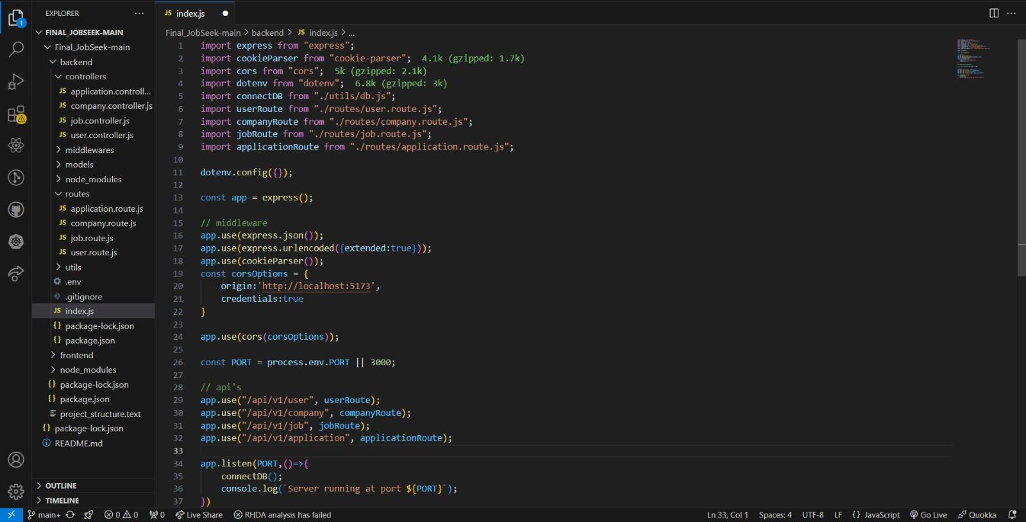

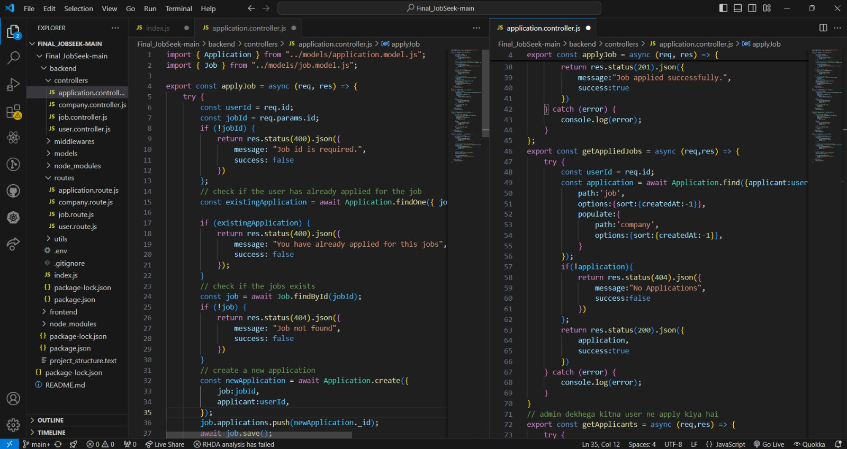

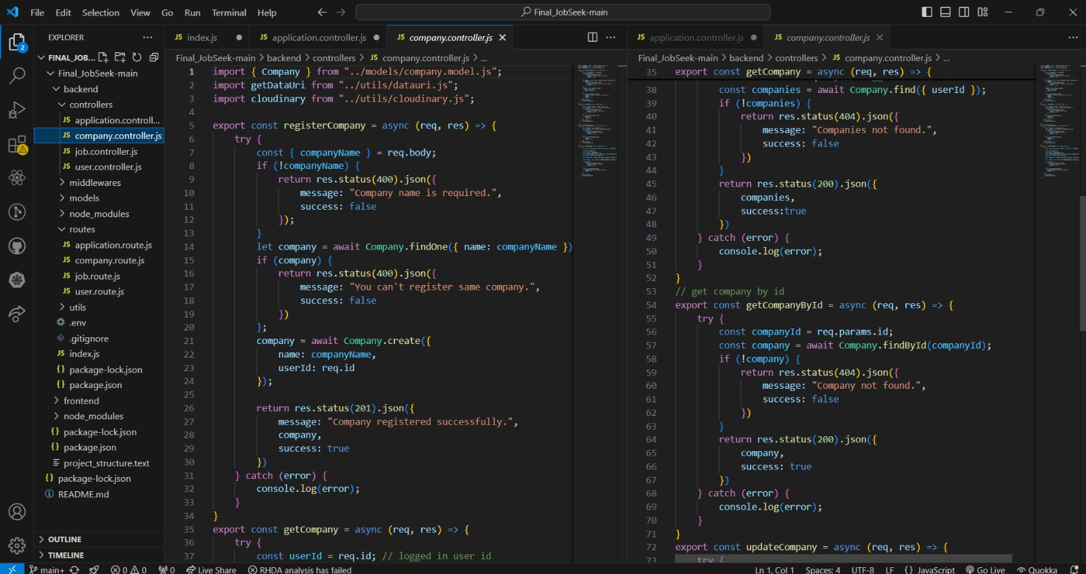

9
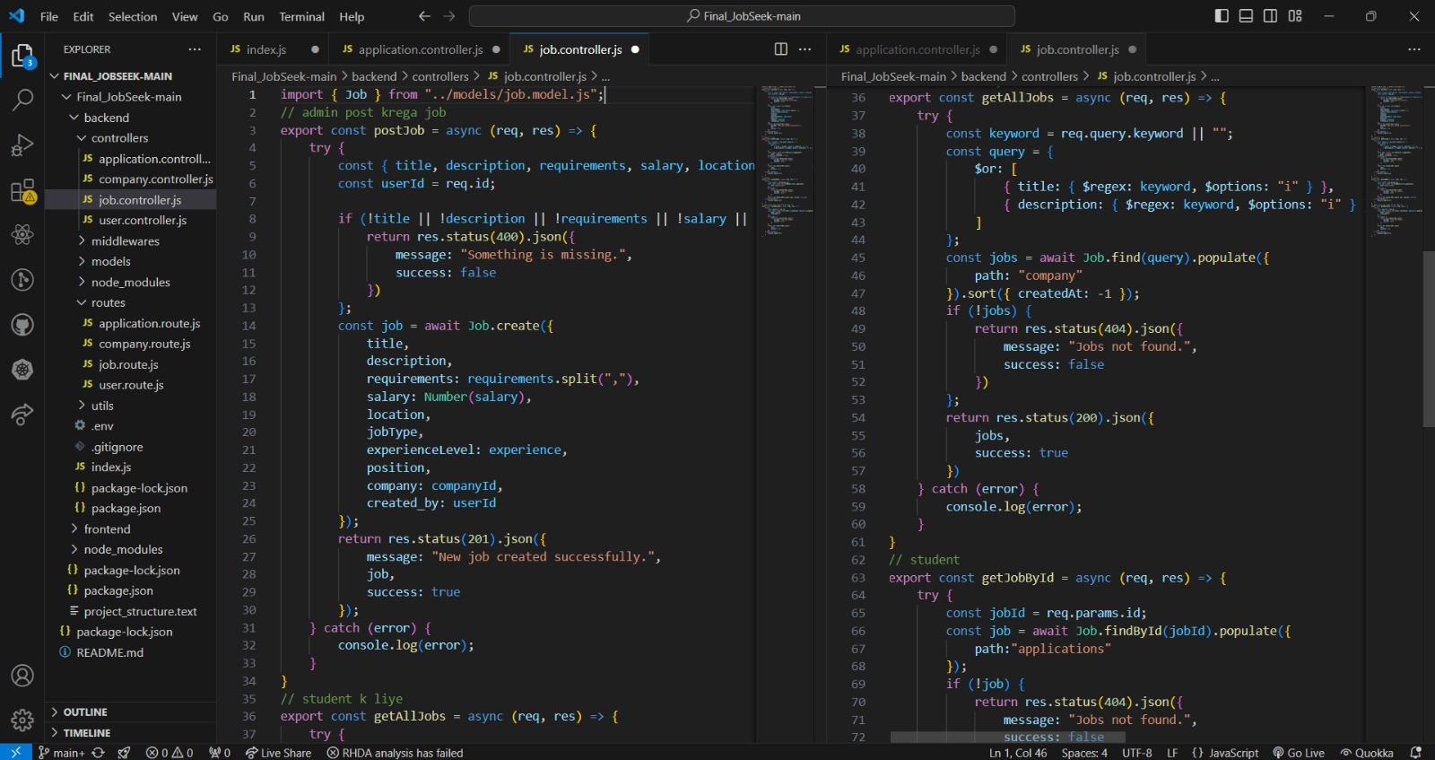

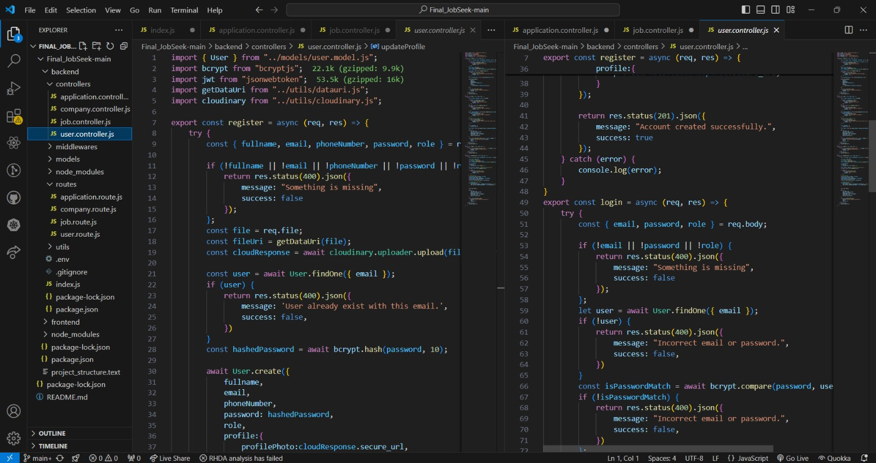

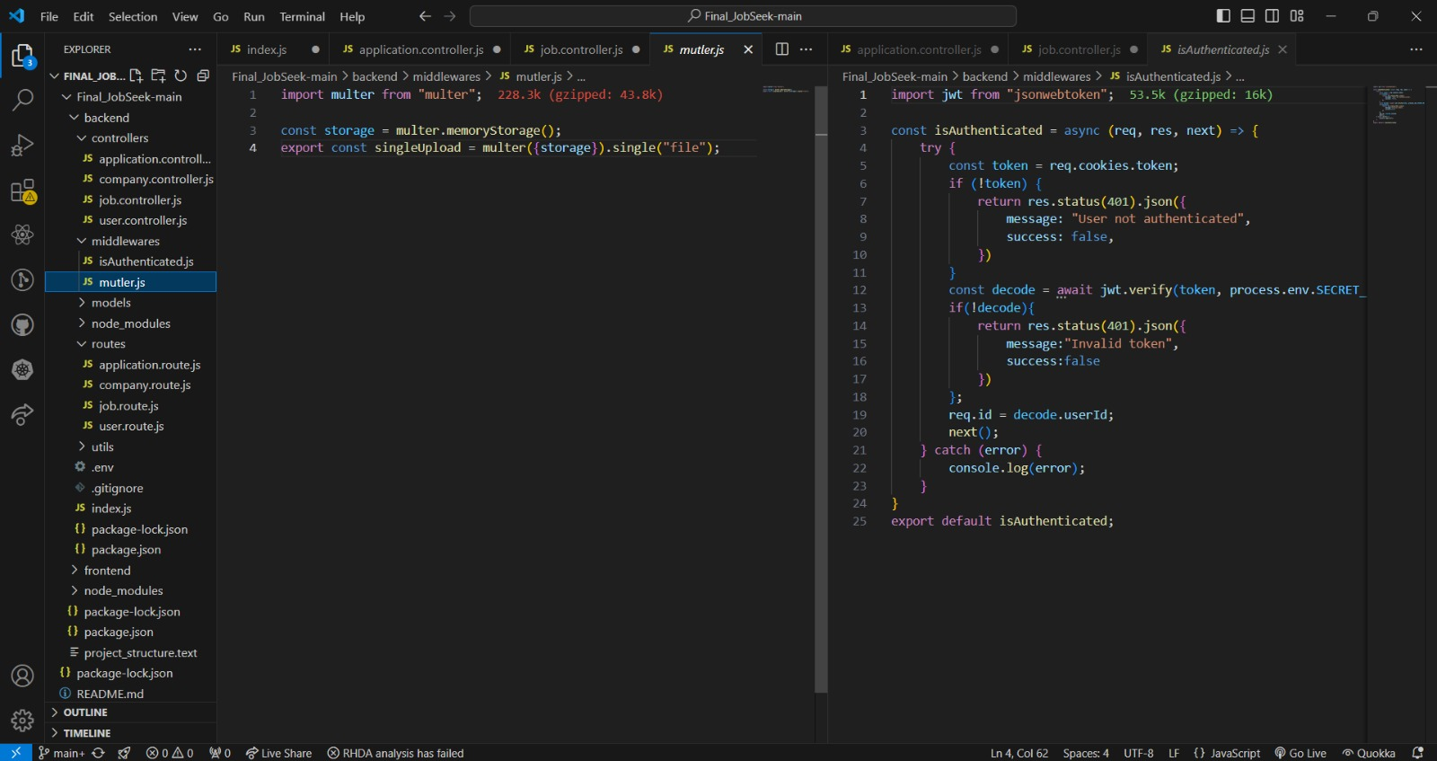
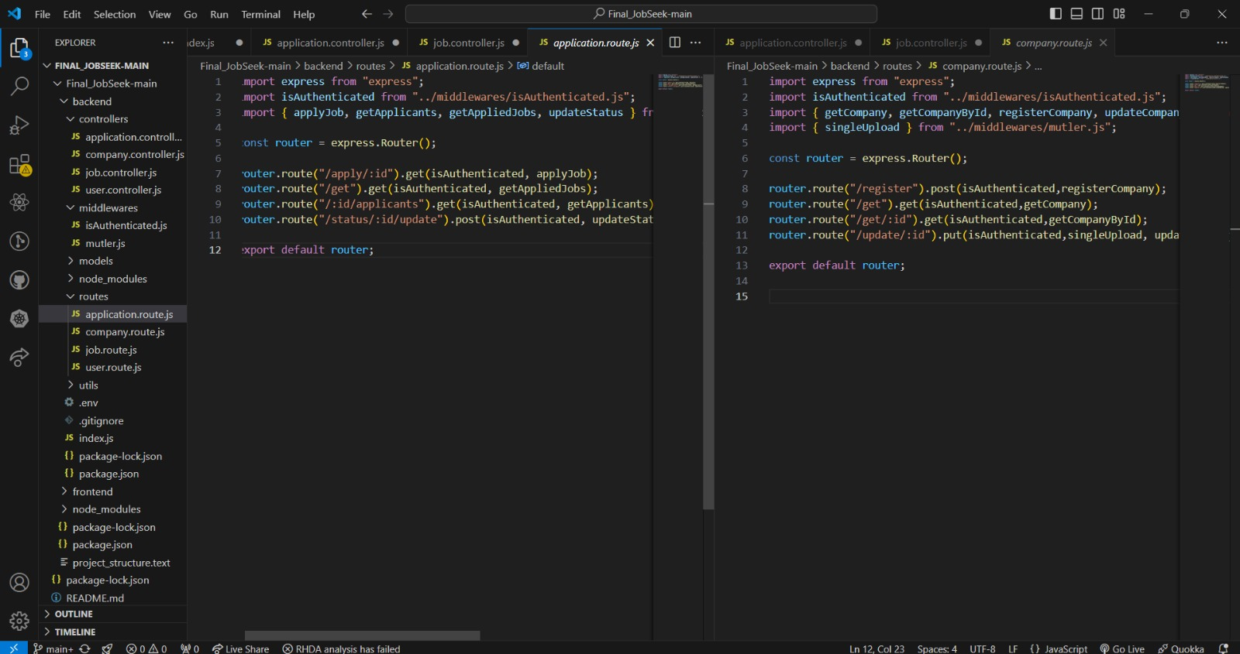

Conclusion

The JobAspire project showcases the potential of modern web technologies in revolutionizing the job search and recruitment process.

A seamless interface ensures that job searching, application submissions, and employer interactions are easy and intuitive.

Built with a robust tech stack, including React.js, Node.js, and MongoDB, the platform delivers high performance, scalability, and reliability.

Future updates may include AI-driven job recommendations, advanced analytics for employers, and enhanced real-time status tracking for applications.

This platform is well-positioned to transform the way users engage with the job market, making the process more efficient and user-friendly.

Future Scope
- AI-Powered Job Recommendations:
Future updates can include artificial intelligence (AI) to provide personalized job recommendations to job seekers based on their profiles, preferences, and past applications, enhancing the relevance of job suggestions.

- Mobile Application Development:
A mobile app version of JobAspire could be developed to offer on-the-go access, allowing job seekers and employers to interact and manage applications easily from smartphones and tablets.

- Advanced Analytics for Employers:
Implementing advanced analytics tools for employers to track application trends, evaluate candidate suitability, and optimize recruitment strategies can provide more insights for better hiring decisions.

- Video Interview Integration:
Introducing an integrated video interview feature would allow employers to conduct interviews directly through the platform, improving convenience and streamlining the hiring process.

- Skill Assessment and Testing:
Incorporating skill assessments and tests for candidates could help employers evaluate candidates' capabilities directly through the platform, ensuring a better match for job roles.

- Enhanced Security Features:
As user data grows, additional security features like two-factor authentication (2FA), end-to-end encryption, and secure payment gateways for premium services will further strengthen the system's integrity and user privacy.

- Community and Networking Features:
Adding social networking features such as career-focused forums, networking events, and peer reviews could create a community where job seekers and employers share insights, experiences, and job-related discussions.

Bibliography/References

- Mead, A. (2018). Full-Stack React Projects. Packt Publishing.
- Murray, M. P., et al. (2020). Pro MERN Stack. Apress.
- Casciaro, M., & Mammino, L. (2020). Node.js Design Patterns (3rd ed.). Packt Publishing.
- Mead, A. (2018). Learning Node.js Development. Packt Publishing.
- Wieruch, R. (2020). The Road to React (2nd ed.). Robin Wieruch.
- Node.js, MongoDB and Angular Web Development". Author: Brad Dayley.(2017).
- Dayley, B. (2017). Node.js, MongoDB and Angular Web Development. Addison- Wesley.

